1. **reservedCOMPUTE IN THE CLOUD**

**AMAZON EC2 INSTANCE:**

Amazon EC2 provides a wide selection of instance types optimized to fit different use cases. Instance types comprise varying combinations of CPU, memory, storage, and networking capacity and give you the flexibility to choose the appropriate mix of resources for your applications. Each instance type includes one or more instance sizes, allowing you to scale your resources to the requirements of your target workload.

There are five types of Amazon EC2 instances:

* **General purpose -** provide a balance of compute, memory, and networking resources
* **Compute optimized -** are ideal for compute-bound applications that benefit from high-performance processors
* **Memory optimized -** are designed to deliver fast performance for workloads that process large datasets in memory
* **Accelerated computing -** use hardware accelerators, or coprocessors, to perform some functions more efficiently than is possible in software running on CPUs.
* **Storage optimized -** are designed for workloads that require high, sequential read and write access to large datasets on local storage. (For Data warehousing)

**AMAZON EC2 PRICING:**

There are five categories we can choose our pricing:

* **On-demand –** ideal for short-term, irregular workloads that cannot be interrupted. No upfront costs or minimum contracts apply
* **Reserved –** are a billing discount applied to the use of On-Demand Instances in your account. There are two available types of Reserved Instances:
* **Standard Reserved Instances :** This option is a good fit if you know the EC2 instance type and size you need for your steady-state applications and in which AWS Region you plan to run them
* **Convertible Reserved Instances :** If you need to run your EC2 instances in different Availability Zones or different instance types, then Convertible Reserved Instances might be right for you.
* **EC2 instances savings plan –** reduce your EC2 instance costs when you make an hourly spend commitment to an instance family and Region for a 1-year or 3-year term. This term commitment results in savings of up to 72 percent compared to On-Demand.
* **Spot instance –** are ideal for workloads with flexible start and end times, or that can withstand interruptions. Spot Instances use unused Amazon EC2 computing capacity and offer you cost savings at up to 90% off of On-Demand prices.
* **Dedicated hosts –** are physical servers with Amazon EC2 instance capacity that is fully dedicated to your use. (Expensive)

**Amazon EC2 Auto Scaling**

Within Amazon EC2 Auto Scaling, you can use two approaches: dynamic scaling and predictive scaling.

**Dynamic scaling** responds to changing demand.

**Predictive scaling** automatically schedules the right number of Amazon EC2 instances based on predicted demand.

**Elastic Load Balancing**

Elastic Load Balancing is the AWS service that automatically distributes incoming application traffic across multiple Amazon EC2 instances.

**MESSAGING AND QUEUEING SERVICE:**

These services are used to communicate between resources within AWS. Two services facilitate application integration:

* **Amazon Simple Notification Service (Amazon SNS) –** Using Amazon SNS topics, a publisher publishes messages to subscribers.
* **Amazon Simple Queue Service (Amazon SQS) –** In Amazon SQS, an application sends messages into a queue. A user or service retrieves a message from the queue, processes it, and then deletes it from the queue.

**AWS LAMBDA**

AWS Lambda is a service that lets you run code without needing to provision or manage servers.

**CONTAINERS**

Containers provide you with a standard way to package your application's code and dependencies into a single object. You can also use containers for processes and workflows in which there are essential requirements for security, reliability, and scalability.

* **Amazon Elastic Container Service (Amazon ECS)**

Amazon Elastic Container Service (Amazon ECS) is a highly scalable, high-performance container management system that enables you to run and scale containerized applications on AWS.

* **Amazon Elastic Kubernetes Service (Amazon EKS)**

Amazon Elastic Kubernetes Service (Amazon EKS) is a fully managed service that you can use to run Kubernetes on AWS.

**AWS Fargate**

AWS Fargate is a serverless compute engine for containers. It works with both Amazon ECS and Amazon EKS.

1. **GLOBAL INFRASTRCUTURE AND RELIABILITY**

**FOUR BUSINESS FACTORS FOR SELECTING A REGION:**

* Compliance with Data governance and legal requirements
* Proximity to your customers
* Available service within region
* Pricing

**Region > Availability Zone > Data center**

**EDGE LOCATIONS**

An edge location is a site that **Amazon CloudFront** uses to store cached copies of your content closer to your customers for faster delivery.

**WAYS TO INTERACT WITH AWS SERVICES**

* **AWS Management Console**
* **AWS Command Line Interface (AWS CLI)**
* **Software development kits (SDKs) -** through an API designed for your programming language or platform

**AWS ELASTIC BEANSTALK**

With AWS Elastic Beanstalk, you provide code and configuration settings, and Elastic Beanstalk deploys the resources necessary to perform the following tasks:

* Adjust capacity
* Load balancing
* Automatic scaling
* Application health monitoring

**AWS CLOUDFORMATION**

With AWS CloudFormation, you can treat your infrastructure as code. This means that you can build an environment by writing lines of code instead of using the AWS Management Console to individually provision resources.

1. **NETWORKING**

**AMAZON VIRTUAL PRIVATE CLOUD**

A networking service that you can use to establish boundaries around your AWS resources is Amazon Virtual Private Cloud (Amazon VPC). A subnet is a section of a VPC that can contain resources such as Amazon EC2 instances.

An **internet gateway** is a connection between a VPC and the internet.

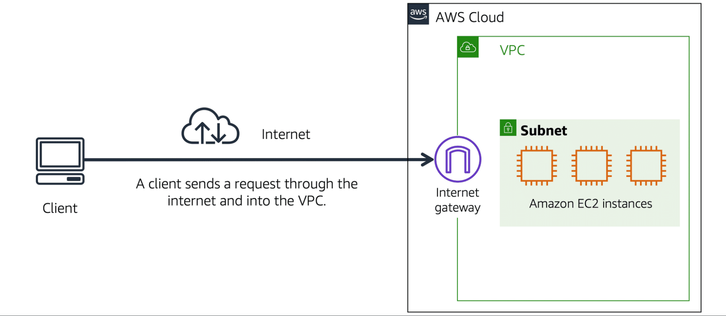

The **virtual private gateway** is the component that allows protected internet traffic to enter into the VPC.

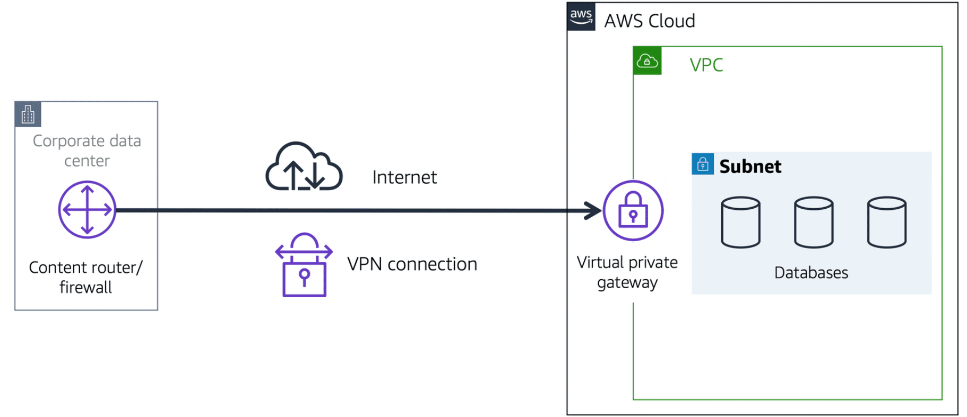

**AWS DIRECT CONNECT**

AWS Direct Connect is a service that lets you to establish a dedicated private connection between your data center and a VPC.

**Subnets**

A subnet is a section of a VPC in which you can group resources based on security or operational needs. Subnets can be public or private.

* **Public subnets** contain resources that need to be accessible by the public, such as an online store’s website.
* **Private subnets** contain resources that should be accessible only through your private network, such as a database that contains customers’ personal information and order histories.

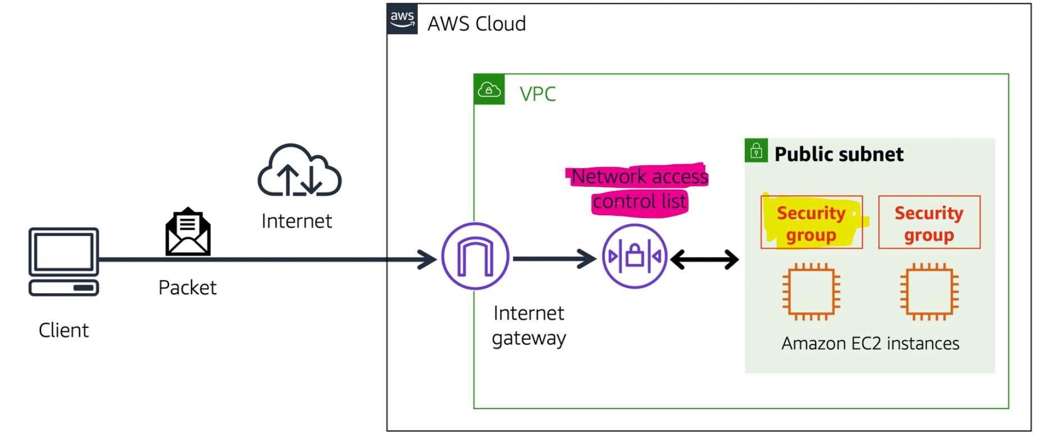

**NETWORK ACLS**

A network ACL is a virtual firewall that controls inbound and outbound traffic at the subnet level.

Network ACLs perform stateless packet filtering. They remember nothing and check packets that cross the subnet border each way: inbound and outbound.

**SECURITY GROUPS**

A security group is a virtual firewall that controls inbound and outbound traffic for an Amazon EC2 instance.

Security groups perform stateful packet filtering. They remember previous decisions made for incoming packets.

**Domain Name System (DNS)**

Customers enter the web address into their browser, and they are able to access the website. This happens because of Domain Name System (DNS) resolution.

**AMAZON ROUTE 53**

Amazon Route 53 is a DNS web service. It gives developers and businesses a reliable way to route end users to internet applications hosted in AWS. It connects user requests to infrastructure running in AWS. It manage the DNS records for domain names.

1. **STORAGE AND DATABASES**

**INSTANCE STORE**

An instance store provides temporary block-level storage for an Amazon EC2 instance. When the instance is terminated, you lose any data in the instance store.

**AMAZON ELASTIC BLOCK STORE**

Amazon Elastic Block Store (Amazon EBS) is a service that provides block-level storage volumes that you can use with Amazon EC2 instances. If you stop or terminate an Amazon EC2 instance, all the data on the attached EBS volume remains available.

We can take incremental backups of EBS volumes by creating **Amazon EBS snapshots**.

**AMAZON SIMPLE STORAGE SERVICE (AMAZON S3)**

Amazon Simple Storage Service (Amazon S3) is a service that provides object-level storage. Amazon S3 stores data as objects in buckets. We can upload any type of file to Amazon S3, such as images, videos, text files, and so on.

**8 DIFFERENT AMAZON S3 STORAGE CLASSES**

1. **S3 STANDARD**

* Designed for frequently accessed data
* Stores data in a minimum of three Availability Zones

1. **S3 STANDARD-INFREQUENT ACCESS (S3 STANDARD-IA)**

* Ideal for infrequently accessed data
* Similar to Amazon S3 Standard but has a lower storage price and higher retrieval price

1. **S3 ONE ZONE-INFREQUENT ACCESS (S3 ONE ZONE-IA)**

* Stores data in a single Availability Zone
* Has a lower storage price than Amazon S3 Standard-IA

1. **S3 INTELLIGENT-TIERING**

* Ideal for data with unknown or changing access patterns
* Requires a small monthly monitoring and automation fee per object

1. **S3 GLACIER INSTANT RETRIEVAL**

* Works well for archived data that requires immediate access
* Can retrieve objects within a few milliseconds

1. **S3 GLACIER FLEXIBLE RETRIEVAL**

* Low-cost storage designed for data archiving
* Able to retrieve objects within a few minutes to hours

1. **S3 GLACIER DEEP ARCHIVE RETRIEVAL**

* Lowest-cost object storage class ideal for archiving
* Able to retrieve objects within 12 hours

1. **S3 OUTPOSTS**

* Creates S3 buckets on Amazon S3 Outposts
* Make it easier to retrieve, store, and access data on AWS Outposts

**AMAZON ELASTIC FILE SYSTEM**

Amazon Elastic File System (Amazon EFS)is a scalable file system used with AWS Cloud services and on-premises resources. It stores data in and across multiple Availability Zones.

The duplicate storage enables you to access data concurrently from all the Availability Zones in the Region where a file system is located. Additionally, on-premises servers can access Amazon EFS using AWS Direct Connect.

**AMAZON RELATIONAL DATABASE SERVICE (AMAZON RDS)**

It is a service that enables you to run relational databases in the AWS Cloud.

**Amazon Aurora**

Amazon Aurora is an enterprise-class relational database. Amazon RDS storing data in Amazon Aurora DB

**AMAZON DYNAMODB**

Amazon DynamoDB is a key-value database service(NoSQL/Non-relational Database). It delivers single-digit millisecond performance at any scale.

**AMAZON REDSHIFT**

Amazon Redshift is a data warehousing service that you can use for big data analytics. It offers the ability to collect data from many sources and helps you to understand relationships and trends across your data.

**AWS DATABASE MIGRATION SERVICE (AWS DMS)**

AWS Database Migration Service (AWS DMS) enables you to migrate relational databases, nonrelational databases, and other types of data stores. With AWS DMS, you move data between a source database and a target database.

**ADDITIONAL DATABASE SERVICES**

* **Amazon DocumentDB** is a document database service that supports MongoDB workloads. (MongoDB is a document database program.)
* **Amazon Neptune** is a graph database service.
* **Amazon Quantum Ledger Database (Amazon QLDB**) is a ledger database service. We can use Amazon QLDB to review a complete history of all the changes that have been made to your application data.
* **Amazon Managed Blockchain** is a service that you can use to create and manage blockchain networks with open-source frameworks.
* **Amazon ElastiCache** is a service that adds caching layers on top of your databases to help improve the read times of common requests.
* **Amazon DynamoDB Accelerator (DAX)** is an in-memory cache for DynamoDB.

1. **SECURITY**

**AWS SHARED RESPONSIBILITY MODEL**

1. **Customers (Security in the cloud)** are responsible for

* maintain complete control over your content
* access rights are granted, managed, and revoked on content
* Security steps include selecting, configuring, and patching the operating systems that will run on Amazon EC2 instances, configuring security groups, and managing user accounts.

1. **AWS (Security of the cloud)** are responsible for

* Physical security of data center
* Hardware and software infrastructure
* Network infrastructure
* Virtualization infrastructure
* Maintaining servers that run Amazon EC2 instances
* protecting the global infrastructure (includes AWS Regions, Availability Zones, and edge locations)

**AWS IDENTITY AND ACCESS MANAGEMENT (IAM)**

AWS Identity and Access Management (IAM) enables you to manage access to AWS services and resources securely.

* When you first create an AWS account, you begin with an identity known as the **root user**.
* An **IAM user** is an identity that you create in AWS
* An **IAM policy** is a document that allows or denies permissions to AWS services and resources.
* An **IAM group** is a collection of IAM users. When you assign an IAM policy to a group, all users in the group are granted permissions specified by the policy.
* An **IAM role** is an identity that you can assume to gain temporary access to permissions.
* In IAM, **multi-factor authentication (MFA)** provides an extra layer of security for your AWS account.

**AWS ORGANIZATIONS**

It is to consolidate and manage multiple AWS accounts within a central location.

In AWS Organizations, you can centrally control permissions for the accounts in your organization by using **service control policies** (SCPs). SCPs enable you to place restrictions on the AWS services, resources, and individual API actions that users and roles in each account can access. We can apply service control policies (SCPs) to the organization root, an individual member account, or an OU.

**AWS ARTIFACT (like auditing)**

It is a service that provides on-demand access to AWS security and compliance reports and select online agreements. AWS Artifact consists of two main sections:

* **AWS Artifact Agreements** - Suppose that your company needs to sign an agreement with AWS regarding your use of certain types of information throughout AWS services. You can do this through AWS Artifact Agreements.
* **AWS Artifact Reports** - suppose that a member of your company’s development team is building an application and needs more information about their responsibility for complying with certain regulatory standards. You can advise them to access this information in AWS Artifact Reports.

**DENIAL-OF-SERVICE ATTACKS**

A denial-of-service (DoS) attack is a deliberate attempt to make a website or application unavailable to users.

**AWS SHIELD**

AWS Shield is a service that protects applications against DDoS attacks. AWS Shield provides two levels of protection:

1. **AWS Shield Standard** - automatically protects all AWS customers at no cost. It protects your AWS resources from the most common, frequently occurring types of DDoS attacks.
2. **AWS Shield Advanced** - paid service that provides detailed attack diagnostics and the ability to detect and mitigate sophisticated DDoS attacks.

**AWS KEY MANAGEMENT SERVICE (AWS KMS)**

You must ensure that your applications’ data is secure while in storage (encryption at rest) and while it is transmitted, known as encryption in transit.

It enables you to perform encryption operations through the use of cryptographic keys.

**AWS WAF**

AWS WAF is a web application firewall that lets you monitor network requests that come into your web applications. AWS WAF works together with Amazon CloudFront and an Application Load Balancer.

**AMAZON INSPECTOR**

Amazon Inspector helps to improve the security and compliance of applications by running automated security assessments. It checks applications for security vulnerabilities and deviations.

**AMAZON GUARDDUTY**

Amazon GuardDuty is a service that provides intelligent threat detection for your AWS infrastructure and resources.

1. **MONITORING AND ANALYTICS**

**AMAZON CLOUDWATCH**

Amazon CloudWatch is a web service that enables you to monitor and manage various metrics and configure alarm actions based on data from those metrics.

We can create alarms **(CloudWatch Alarm**) that automatically perform actions if the value of your metric has gone above or below a predefined threshold.

The **CloudWatch dashboard** feature enables you to access all the metrics for your resources from a single location.

**AWS CLOUDTRAIL**

AWS CloudTrail records API calls for your account.

Within CloudTrail, you can also enable **CloudTrail Insights.** This optional feature allows CloudTrail to automatically detect unusual API activities in your AWS account. Filter logs to assist with operational analysis and troubleshooting.

**AWS TRUSTED ADVISOR**

AWS Trusted Advisor is a web service that inspects your AWS environment and provides real-time recommendations in accordance with AWS best practices.

**AWS TRUSTED ADVISOR DASHBOARD**

When you access the Trusted Advisor dashboard on the AWS Management Console, you can review completed checks for cost optimization, performance, security, fault tolerance, and service limits.

1. **PRICING AND SUPPORT**

**AWS FREE TIER**

The AWS Free Tier enables you to begin using certain services without having to worry about incurring costs for the specified period.

Three types of offers are available:

**Always Free** - These offers do not expire and are available to all AWS customers**.**

**12 Months Free** - These offers are free for 12 months following your initial sign-up date to AWS.

**Trials** - Short-term free trial offers start from the date you activate a particular service. The length of each trial might vary by number of days or the amount of usage in the service.

**AWS PRICING CALCULATOR**

The AWS Pricing Calculator lets you explore AWS services and create an estimate for the cost of your use cases on AWS.

**BILLING DASHBOARD**

AWS Billing & Cost Management dashboard to pay your AWS bill, monitor your usage, and analyze and control your costs.

**CONSOLIDATED BILLING**

The consolidated billing feature of AWS Organizations enables you to receive a single bill for all AWS accounts in your organization.

**AWS BUDGETS**

In AWS Budgets, you can create budgets to plan your service usage, service costs, and instance reservations. The information in AWS Budgets updates three times a day. This helps you to accurately determine how close your usage is to your budgeted amounts or to the AWS Free Tier limits.

**AWS COST EXPLORER**

AWS Cost Explorer is a tool that lets you visualize, understand, and manage your AWS costs and usage over time.

**AWS SUPPORT**

AWS offers four different Support plans to help you troubleshoot issues, lower costs, and efficiently use AWS services. Basic is default. If your company needs support beyond the Basic level, we can purchase other support.

**Basic**

**Developer** - Best practice guidance, Client-side diagnostic tools, Building-block architecture support

**Business** - Use-case guidance to identify AWS offerings, features, and services that can best support your specific needs, All AWS Trusted Advisor checks, Limited support for third-party software

**Enterprise On-Ramp** - A pool of Technical Account Managers to provide proactive guidance and coordinate access to programs and AWS experts, A Cost Optimization workshop (one per year), A Concierge support team for billing and account assistance, Tools to monitor costs and performance through Trusted Advisor and Health API/Dashboard

**Enterprise** - A designated Technical Account Manager to provide proactive guidance and coordinate access to programs and AWS experts, A Concierge support team for billing and account assistance, Operations Reviews and tools to monitor health, Training and Game Days to drive innovation, Tools to monitor costs and performance through Trusted Advisor and Health API/Dashboard.

**TECHNICAL ACCOUNT MANAGER (TAM)**

The TAM is your primary point of contact at AWS. The Enterprise On-Ramp and Enterprise Support plans include access to a TAM.

**AWS MARKETPLACE**

AWS Marketplace is a digital catalog that includes thousands of software listings from independent software vendors. You can use AWS Marketplace to find, test, and buy software that runs on AWS.

**AWS CLOUD ADOPTION FRAMEWORK (AWS CAF)**

There are Six core perspectives of the Cloud Adoption Framework.

Business, People, and Governance Perspectives focus on business capabilities. Platform, Security, and Operations Perspectives focus on technical capabilities.

The **Business Perspective** ensures that IT aligns with business needs and that IT investments link to key business results.(Business managers, Finance managers, Budget owners, Strategy stakeholders)

The **People Perspective** supports development of an organization-wide change management strategy for successful cloud adoption. (Human resources, Staffing, People managers)

The **Governance Perspective** focuses on the skills and processes to align IT strategy with business strategy. This ensures that you maximize the business value and minimize risks. (Chief Information Officer (CIO), Program managers, Enterprise architects, Business analysts, Portfolio managers)

The **Platform Perspective** includes principles and patterns for implementing new solutions on the cloud, and migrating on-premises workloads to the cloud. (Chief Technology Officer (CTO), IT managers, Solutions architects)

The **Security Perspective** ensures that the organization meets security objectives for visibility, auditability, control, and agility. (Chief Information Security Officer (CISO), IT security managers, IT security analysts)

The **Operations Perspective** helps you to enable, run, use, operate, and recover IT workloads to the level agreed upon with your business stakeholders. (IT operations managers, IT support managers)

**6 STRATEGIES FOR MIGRATION FROM ON-PREMISES CLOUD TO AWS:**

1. Rehosting - moving applications without changes.
2. Replatforming - making a few cloud optimizations to realize a tangible benefit.
3. Refactoring/re-architecting - reimagining how an application is architected and developed by using cloud-native features
4. Repurchasing- moving from a traditional license to a software-as-a-service model.
5. Retaining - keeping applications that are critical for the business in the source environment.
6. Retiring - process of removing applications that are no longer needed.

**AWS SNOW FAMILY**

The AWS Snow Family is a collection of physical devices that help to physically transport up to exabytes of data into and out of AWS. AWS Snow Family is composed of

**AWS Snowcone** - 2 CPUs, 4 GB of memory, and up to 14 TB of usable storage.

**AWS Snowball** – 2 Devices

Snowball Edge Storage Optimized devices - 80 TB HDD, 1 TB SDD, 40 vCPU, 80 GB

Snowball Edge Compute Optimized devices - 80 TB HDD, 28TB NVM SSD, 104 vCPU, 416 GB

**AWS Snowmobile** - 100 PB

**INNOVATION**

**Amazon SageMaker**

Traditional machine learning (ML) development is complex, expensive, time consuming, and error prone. AWS offers Amazon SageMaker to remove the difficult work from the process and empower you to build, train, and deploy ML models quickly.

**Amazon CodeWhisperer** - Get code recommendations while writing code and identify security issues in your code.

**Amazon Transcribe** - Convert speech to text.

**Amazon Comprehend** - Discover patterns in text.

**Amazon Fraud Detector** - Identify potentially fraudulent online activities.

**Amazon Lex** - Build voice and text chatbots.

**AWS DeepRacer** - autonomous 1/18 scale race car that you can use to test reinforcement learning models.

**AWS WELL-ARCHITECTED FRAMEWORK**

The AWS Well-Architected Framework helps you understand how to design and operate reliable, secure, efficient, and cost-effective systems in the AWS Cloud.

The Well-Architected Framework is based on six pillars:

**Operational excellence** - ability to run and monitor systems to deliver business value and to continually improve supporting processes and procedures.

**Security** - ability to protect information, systems, and assets while delivering business value through risk assessments and mitigation strategies.

**Reliability** - ability of a system to Recover from infrastructure or service disruptions, Dynamically acquire computing resources to meet demand and Mitigate disruptions such as misconfigurations or transient network issues

**Performance efficiency** - ability to use computing resources efficiently to meet system requirements and to maintain that efficiency as demand changes and technologies evolve.

**Cost** **optimization** - ability to run systems to deliver business value at the lowest price point.

**Sustainability** - ability to continually improve sustainability impacts by reducing energy consumption and increasing efficiency across all components of a workload by maximizing the benefits from the provisioned resources and minimizing the total resources required.

**ADVANTAGES OF CLOUD COMPUTING**

Six advantages of cloud computing:

* Trade upfront expense for variable expense.
* Benefit from massive economies of scale.
* Stop guessing capacity.
* Increase speed and agility.
* Stop spending money running and maintaining data centers.
* Go global in minutes.

**AWS re:Post**

AWS re:Post is an AWS-managed Q&A service offering crowd-sourced, expert-reviewed answers to your technical questions about AWS that replaces the original AWS Forums.

**AMAZON ATHENA**

Amazon Athena is an interactive query service that makes it easy to analyze data directly in Amazon Simple Storage Service (Amazon S3) using standard SQL.

**AMAZON EMR**

Amazon EMR (Elastic MapReduce) is a web service that makes it easy to process vast amounts of data efficiently using Apache Hadoop and services offered by Amazon Web Services.

**AWS GLUE**

AWS Glue is a scalable, serverless data integration service that makes it easy to discover, prepare, and combine data for analytics, machine learning, and application development.

**AMAZON KINESIS**

Amazon Kinesis makes it easy to collect, process, and analyze video and data streams in real time.

**AMAZON MSK**

Amazon Managed Streaming for Apache Kafka (Amazon MSK) is a fully managed service that makes it easy for you to build and run applications that use Apache Kafka to process streaming data.

**AMAZON OPENSEARCH SERVICE**

Amazon OpenSearch Service is a managed service that makes it easy to deploy, operate, and scale OpenSearch, a popular open-source search and analytics engine. OpenSearch Service also offers security options, high availability, data durability, and direct access to the OpenSearch API.

**AMAZON QUICKSIGHT**

Amazon QuickSight is a fast business analytics service to build visualizations, perform ad hoc analysis, and quickly get business insights from your data. Amazon QuickSight seamlessly discovers AWS data sources, enables organizations to scale to hundreds of thousands of users, and delivers fast and responsive query performance by using the Amazon QuickSight Super-fast, Parallel, In-Memory, Calculation Engine (SPICE).

**AMAZON MACHINE IMAGE**

Amazon Machine Image (AMI) provides the information required to launch an instance.

**AWS OUTPOSTS**

AWS Outposts is a fully managed service that offers the same AWS infrastructure, AWS services, APIs, and tools to virtually any datacenter, co-location space, or on-premises facility for a truly consistent hybrid experience. With AWS Outposts you can extend your VPC into the on-premises data center.

**COST ALLOCATION TAGS**

Cost allocation tags can be used to tag and categorize your resources and then run view the billing in Cost Explorer and the cost allocation report. It is used to categorize and track AWS costs by project

**AMAZON MACIE**

Amazon Macie is a fully managed data security and data privacy service that uses machine learning and pattern matching to discover and protect your sensitive data in AWS. Amazon Macie automates the discovery of sensitive data at scale and lowers the cost of protecting your data.

Macie automatically provides an inventory of Amazon S3 buckets including a list of unencrypted buckets, publicly accessible buckets, and buckets shared with AWS accounts outside those you have defined in AWS Organizations.

Then, Macie applies machine learning and pattern matching techniques to the buckets you select to identify and alert you to sensitive data, such as personally identifiable information (PII).

**AWS CODECOMMIT**

AWS CodeCommit is a fully-managed source control service that hosts secure Git-based repositories. It makes it easy for teams to collaborate on code in a secure and highly scalable ecosystem.

CodeCommit eliminates the need to operate your own source control system or worry about scaling its infrastructure. You can use CodeCommit to securely store anything from source code to binaries, and it works seamlessly with your existing Git tools.

**SOFTWARE DEVELOPMENT KIT (SDK)**

A software development kit (SDK) is a collection of software development tools in one installable package. AWS provide SDKs for various programming languages and these can be used for integrating the features of AWS services directly into an application.

**AWS CDK**

The AWS Cloud Development Kit (AWS CDK) is an open source software development framework to define cloud application resources using familiar programming languages. With AWS CDK you can stick to using programming languages that are familiar to you and have infrastructure deployed using AWS CloudFormation.

**AWS BILLING CONDUCTOR**

AWS Billing Conductor is a customizable billing service that allows the organization to define billing groups, set pricing rules, create custom line items, and generate a unique Cost and Usage Report (CUR) for each billing group. This service would help the corporation to streamline and customize their billing data efficiently according to different business logics.

**AWS CLOUDHSM**

The AWS CloudHSM service helps you meet corporate, contractual, and regulatory compliance requirements for data security by using dedicated Hardware Security Module (HSM) instances within the AWS cloud. AWS CloudHSM enables you to easily generate and use your own encryption keys on the AWS Cloud.

Every region is interconnected via bandwidth and fully redundant network.

**6 Advantages of cloud computing:**

1. Trade capital expense for variable expense
2. Benefits from massive economies of scale
3. Stop guessing capacity
4. Increase speed and agility
5. Stop spending money running and maintaining data centre
6. Go global in minutes

The AWS Acceptable Use Policy describes the prohibited uses of AWS

**IAM POLICY**

User-based policy applied to user, role and group

Resource-based policy applied to resources such as S3 bucket

**IAM BEST PRACTICES**

* Require human user to use federation with an identity provider to access AWS using temporary credentials
* Require workload to use temporary credentials with IAM roles to access AWS
* Require MFA
* Rotate access key regularly
* Safeguard your root user credentials and don’t use them for everyday tasks
* Apply least privilege permission
* Get started with AWS managed policies and move towards least privilege policies.
* Use IAM access Analayzer to generate least-privilege permission based on access activity
* Regularly review and remove unused users, roles, permissions, policies and credentials

**Virtual server – Instances**

Amazon Machine Image(AMI) – Defines the configuration of the instance

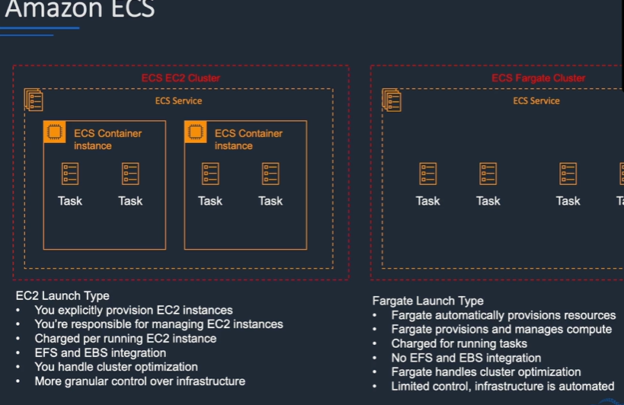

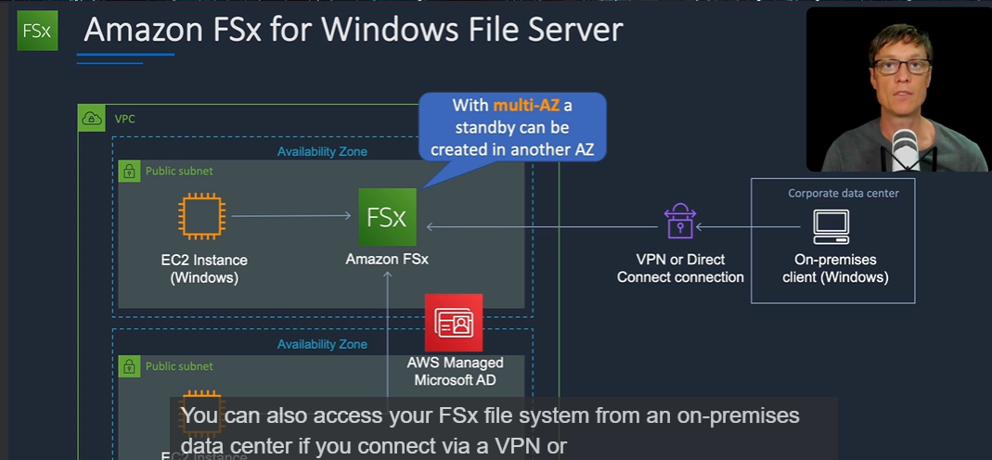

S3 object lock: object store only using a WORM (Write once Read many)

System manager manages your AWS resources, such as EC2 instances, Amazon S3, and RDS.

AWS Service Catalog is a service which we can use to create catalogs of IT services that we can then pre-approve for consumption on AWS.

The AWS config service is used for viewing and managing the configuration of your resources on AWS

AWS Launch wizard offers a guided way of sizing configuring and deploying resources on Aws for third party applications.